**THE MAHARAJA SAYAJIRAO UNIVERSITY OF BARODA**

Faculty of Science



**Internship Report**

*On*

**Emotion Recognition with Convolutional Neural Network**

*for*

**Rishabh Software Pvt. Ltd.**

*Submitted by:*

**Vraj Kotwala – 622079**

*In fulfilment of the degree*

*Of*

**Bachelors of Computer Applications**

*In*

**Department of Computer Applications**

July, 2020

**External Guide: Internal Guide:**

Mr. Gagan Dubey Mr. Kshitij Tripathi

Dr. Falguni Ranadive

**The Maharaja Sayajirao University of Baroda**

**Faculty of Science**

**Department of Computer Applications.**

**Date**: 7th July 2020

Vraj Kotwala

Seat no: 622079

Internship Report

**EmotiBot – Emotion Recognition with Convolutional Neural Network**

Invigilator Signature__________________________

|  |
| --- |
| The Maharaja Sayajirao University of Baroda  Faculty of Science  Department of Computer Applications |
| BCA Programme |

Certificate

*This is to certify that Mr./~~Ms.~~**Vraj Kotwala a student of BCA Programme (Seat No. 622079) of The Maharaja Sayajirao University of Baroda, Vadodara, has successfully completed the Internship prescribed for the sixth semester of the programme during the period from 21st January 2020 to 30th June 2020 towards the partial fulfillment for the degree of Bachelor of Computer Applications.*

*Date: 7th July 2020*

|  |  |  |
| --- | --- | --- |
| **Mr. Kshitij Tripathi**  **Guide** | **Prof. H.R. Kataria**  **Director** | **Prof. R.S. Srivastava**  **Head** |

**Acknowledgment**

It is with great pleasure that I present this document as a report of my work done at **Rishabh Software Pvt. Ltd.**

Success cannot be achieved single-handedly. For this reason, I would like to express my deepest gratitude to all those involved in making this project a success. This project would not have been successfully completed without the help of my mentors.

Firstly, I thank **Prof. R.S. Srivastava (H.O.D.)**, associate coordinator of BCA program, who gave me this opportunity which will add to my experience.

I would also like to thank **Mr. Kshitij Tripathi** who provided me guidelines throughout the course of the internship.

Not missing to thank my own **C.A. Department**, for giving me this opportunity to gain practical experience and enable me to understand the demand of the experience and professional environment. I have gained valuable experience which has given me confidence and has enhanced my professional skill for my competent career.

I would also like to thank all our teachers and family members for helping, encouraging and increasing my determination, throughout my studies, especially during the internship period.

I would like to thank Dr. Falguni Ranadive, Mr. Gagan Dubey, Sahil Bali, Paramtap Mewada, Swetika Sharma, and Balaji KS who have facilitated me and explained me the core concepts behind Machine Learning. They were ready to help me whenever I needed.

Special thanks to my intern-colleague, Jayati Goswami, designing the GUI for this project, and for pre-processing the data. Without her help this project would not be possible.

**Contents**

Cover Page 00

College certificate 00

Acknowledgement 04

Abstract 06

I. Introduction 07-15

* 1. Objective 08
  2. Organization 09

1.2.1 Type of Organization 09

1.2.2. Products and Services offered by the Organization 10

1.2.3 The Customers/Client of the Organizations 12

1.2.4 Major Competitors of the Organization 13

1.2.5 Major Strengths of the Organization 14

II. Internship Assignments 15-47

* 1. Method/Resources used to find this Internship 16
  2. Departments of Organization in which I worked 19
  3. Description of each Assignment with screenshot 20-43
     1. Assignment 1: Emotion Recognition 20-37
     2. Assignment 2: Data Mining 38-40
     3. Assignment 3: Regression and NN on MNIST 41-43
  4. Challenges or difficulties faced during each assignment 45
  5. Correlating with the Academics 46

III. Corporate Culture 47-53

3.1 Working Atmosphere 48

3.2 Culture within the Organization 49

3.2.1 Cultural norms 49-50

3.2.2 Cultural norms I picked up 51

3.2.3 Insights gained about corporate culture 52

IV. Communication 53-57

4.1 Ways in which I communicated within and outside the organization 54

4.2 Examples of good communication skills utilized by the employees 55

4.3 Methods to improve the effectiveness of comm. within the organization 56

V. Career Reflection 57

5.1 Internship related to field of study 58

5.2 List out the technologies learned during the internship 59

Conclusion: Experience and learning 60

References and Bibliography 61-62

**Abstract**

During the period of my internship at Rishabh Software Pvt Ltd, I was given a proper training regarding how to handle the project in a proficient and methodical manner by my guides, Dr. Falguni Ranadive, Mr. Gagan Dubey Sahil Bali, Paramtap Mewada and Swetika Sharma at the organisation.

This report contains the work done by me at the organisation from the period from Jan 2020 to June 2020. The challenges faced during the period of internship in term of working on projects and mini tasks are produced in this report.

I have had implemented an Emotion Recognition System for Mass Surveillance in order to monitor a group of citizens, or a substantial fraction of a population.

The internship report describes my objective of doing this internship and thereby meeting the goals I had set for myself as an individual in view of learning and matching up to the need of working as a professional in a corporate environment.

Some of the details of the project are not to be disclosed in this document as per company’s policy.

* **Emotion recognition** is the process of identifying human [emotion](https://en.wikipedia.org/wiki/Emotion).
* The software can detect 7 different emotions (Angry, Sad, Happy, Disgusted, Fearful, Neutral and Surprised).
* It uses your system's webcam to capture your face.
* The captured emotions are stored into the database with timestamp to perform further statistical analysis.

I. Introduction

1.1 **Objective**:

The purpose of choosing this internship was to acquire practical skills, experience and to get an opportunity to establish relationships with employers and employees in IT field.

Choosing internship over the project helped me get familiar with the corporate culture. The corporate exposure which I received during the course of this internship is invaluable and it taught me discipline.

This internship also helped me develop skills in the practical work situations.

1.2. **Organisation:**



<https://www.rishabhsoft.com/>

1.2.1 **Type of Organisation**:

Rishabh Software provides software, recruitment and engineering services and solutions to mid-sized enterprises globally. Through Rishabh's experience in mobile, web, cloud and analytics solutions, our technology clients get the best value for their IT budget. The company has been appraised for CMMi Level-3, ISO9001 and ISO27001 as well as been awarded for its Innovation in Gujarat.

Since its inception in 1999, Rishabh Software has proudly delivered over 1000+ successful projects to its customers across 23 countries including USA, UK, Europe, Canada, Australia.

It is both product-based and service-based company.

1.2.2 **Products and services offered by Rishabh Software**:

**Mobile App Development Services**

1. IOS App Development
2. Android App Development
3. Xamarin App Development
4. Cross Platform App Development

**Web Application Development**

1. Drupal Development
2. Ecommerce
3. Web Development Services
4. Magneto Development
5. Zen Cart Development
6. Portals + Collaboration

**PHP Development Services**

1. Laravel Development

**Microsoft Development Services & Solutions**

1. .Net Development
2. Sharepoint Development
3. Dynamics CRM

**Front End Development**

1. Angular Development

**Enterprise Application Development Services**

1. App Re-Engineering + Modernization
2. Enterprise Application Integration Services
3. Application Maintenance

**Cloud Development**

1. SAAS App Development
2. Cloud Integration

**Business Intelligence Services**

**Java Development Services & Solutions**

**QA & Software Testing Services**

**Business Process Outsourcing** (BPO):

1. Recruitment Process Outsourcing
2. Payroll Processing
3. Tax Form Processing
4. Accounting and Bookkeeping

**Knowledge Process Outsourcing (KPO)**

**Engineering Design Services**:

1. [Engineering Services](http://www.rishabheng.com/engineering-services/)
2. [CAD Design Services](http://www.rishabheng.com/cad-design-services/)
3. [Stress Analysis Services](http://www.rishabheng.com/specialized-engineering-services/)
4. [Pre-Project Planning](http://www.rishabheng.com/pre-project-planning/)

**Industry:**

1. [Education](https://www.rishabhsoft.com/education-solutions)
2. [Finance](https://www.rishabhsoft.com/banking-finance-solutions)
3. [Healthcare](https://www.rishabhsoft.com/healthcare-medical-solutions)
4. [Digital Enterprise](https://www.rishabhsoft.com/digital-enterprise-solutions)
5. [Logistics & Supply Chain](https://www.rishabhsoft.com/supply-chain-solutions)
6. [Telecom](https://www.rishabhsoft.com/custom-telecom-solutions)
7. [Retail](https://www.rishabhsoft.com/retail-software-solutions)

1.2.3 **Some of their clients**:

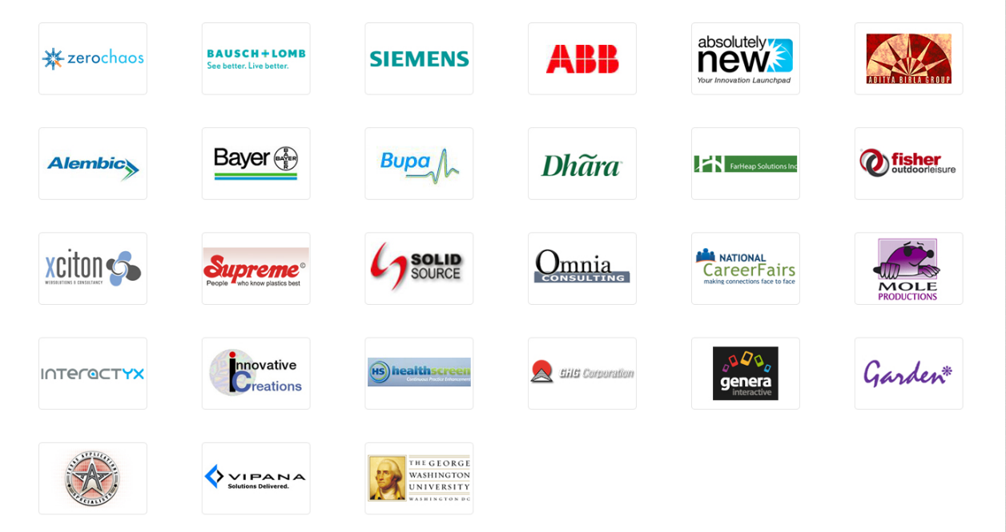

Figure 1: Rishabh Software’s Clients

1. ABB
2. Absolutely New
3. Aditya Birla Group
4. Alembic
5. Bausch + Lomb
6. Bayer
7. Bupa
8. Dhara
9. Far Heap Solutions Inc.
10. Fisher outdoor Leisure
11. GHG Corporation
12. Garden
13. Genera interactive
14. Health Screen
15. Innovative Creations
16. Interactyx
17. Mole Productions
18. National Career Fairs
19. Omnia Consulting
20. Siemens
21. Solid Source
22. Supreme
23. Texas Applications
24. The George Washington University
25. Vipana
26. Xciton
27. Zero Chaos

1.2.4 **Major Competitors of the Organization**

1. Accenture
2. Clavax Technologies LLC.
3. Cognizant
4. Healthera
5. Infosys
6. KMK Consulting
7. Mindinventory Company
8. Ncode Technologies
9. Sanovi
10. Smarther
11. Solution Analysts Pvt Ltd
12. TCS
13. WebSenor InfoTech
14. Wipro
15. Xicom Technologies Ltd.
16. iShore Software1.2.5 **Major Strengths of the Organization**
17. Nice work environment
18. Spread over 100,000 sq. ft. infrastructure
19. Decent and open work culture
20. The company has CMMI DEV3 certifications
21. It also has the ISO 9001 Bureau Veritas Certifications
22. It delivers software for most industries (i.e. [Education](https://www.rishabhsoft.com/education-solutions), [Finance](https://www.rishabhsoft.com/banking-finance-solutions), [Healthcare](https://www.rishabhsoft.com/healthcare-medical-solutions), [Digital Enterprise](https://www.rishabhsoft.com/digital-enterprise-solutions), [Logistics & Supply Chain](https://www.rishabhsoft.com/supply-chain-solutions), [Telecom](https://www.rishabhsoft.com/custom-telecom-solutions) and [Retail](https://www.rishabhsoft.com/retail-software-solutions))

II. Internship Assignments

2.1 **Resources used to find this Internship**

I had collected a list of IT companies from the internet and websites like internshala.com. Also, my cousin helped me find some companies as she was looking for an internship too as a last year CSE student.

My friend told me about the Rishabh Software. Before he told me about the company I had given interviews in many companies. I also cold-emailed many companies before I got selected in Rishabh Software.

After I visited the premises and given the interview for Rishabh Software I decided to work there. Rishabh Software is one of least companies (in Vadodara) which uses python for software development. Hence, I decided to work there as I always wanted to work with python.

Here is a list of companies which I had shortlisted before joining Rishabh Software:

(*next page*)

|  |  |  |  |  |  |
| --- | --- | --- | --- | --- | --- |
| Sr. No. | Company Name | Contact | Email | City | |
| 1 | ALTUM LABS | 079-48901934 | [connect@altumlabs.com](mailto:connect@altumlabs.com) | Ahmedabad |
| 2 | ANSI BYTECODE LLP | 79 400 85 631 | [info@ansibytecode.com](mailto:info@ansibytecode.com) | Ahmedabad |
| 3 | APPIT SIMPLE INFOTECK PVT. LTD | 7966171721 | [hr@appitsimple.com](mailto:hr@appitsimple.com) | Ahmedabad |
| 4 | BIZNOVARE SOLUTIONS | - | [info@biznovare.com](mailto:info@biznovare.com) | Ahmedabad |
| 5 | Byte Prophecy | 079 6663 0298 | - | Ahmedabad |
| 6 | ClickLearn India Pvt.Ltd. | 079 4032 5465 | - | Ahmedabad |
| 7 | EVOSYS | 079 6682 3300 | [business@evosysglobal.com](mailto:business@evosysglobal.com) | Ahmedabad |
| 8 | INFINITY INFOWAY PVT. LTD. | - | info@infinityinfoway.com | Ahmedabad |
| 9 | Infomize Technology | 079 4840 4688 | [contact@infomize.com](mailto:contact@infomize.com) | Ahmedabad |
| 10 | INFOSTRETCH CORPORATION | 079-67771222 | [info@infostretch.com](mailto:info@infostretch.com) | Ahmedabad |
| 11 | INTUZ SOLUTIONS | 079 4890 2497 | - | Ahmedabad |
| 12 | Sarjen Systems Pvt Ltd | 079 6621 4899 | [reachus@sanmargroup.com](mailto:bj3@sanmargroup.com) | Ahmedabad |
| 13 | Scanpoint Geomatics Ltd. | 070574 54447 | [info@sgligis.com](mailto:info@sgligis.com) | Ahmedabad |
| 14 | SIMFORM SOLUTIONS | 079 4007 0170 | - | Ahmedabad |
| 15 | VIITORCLOUD TECHNOLOGIES | 079 4003 1384 | - | Ahmedabad |
| 16 | WEB OCCULT PVT. LTD. | 079 4800 3449 | [ruchir@weboccult.com](mailto:ruchir@weboccult.com) | Ahmedabad |
| 17 | Guj infotech | 080000 50023 | - | Anand |
| 18 | HRP Software | 087589 56243 | - | Bajwa |
| 19 | JOSHI BIZTECH | 0278 664 1010 | - | Bhavnagar |
| 20 | Full Stack Technology | 094277 71117 | career@fullstacktechnology.com | Gandhinagar |
| 21 | TRELLISOFT |  | jobs@trellissoft.com | Gandhinagar |
| 22 | CAPGEMINI | - | [fresherhiring.in@capgemini.com](mailto:fresherhiring.in@capgemini.com) | Pune |
| 23 | 42Gears | 99809 88606 | [jobs@42gears.com](mailto:jobs@42gears.com) | Rajkot |
| 24 | CASE POINT PVT. LTD. | 095373 65551 | - | Surat |
| 25 | Elaunch solutions | 0261 698 9898 | [info@elaunchinfotech.com](mailto:info@elaunchinfotech.com) | Surat |
| 26 | Siliconbrain | 099794 62778 | - | Surat |
| 27 | SSM INFOTECH | 099740 42150 | - | Surat |
| 28 | WOKONTEC IT solution | 099247 56753 | - | Surat |
| 29 | Adri IT solutions | 088662 44200 | [contact@adriitsolutions.com](mailto:contact@adriitsolutions.com) | Vadodara |
| 30 | Aimtron Electronic Pvt. Ltd. | 096876 32057 | [hrindia@aimtron.com](mailto:hrindia@aimtron.com) | Vadodara |
| 31 | Alivecreate web solutions | 091376 34193 | info@alivecreate.com | Vadodara |
| 32 | Arth technology | 093758 20283 | [contact@arthtechnology.com](mailto:contact@arthtechnology.com) | Vadodara |
| 33 | Ascendtis IT solution | 070164 49735 | [support@ascendtis.com](mainto:support@ascendtis.com) | Vadodara |
| 34 | AXAR Decision Software | 265 330 1669 | [pratik.patel@sikkasoftware.com](mailto:pratik.patel@sikkasoftware.com) | Vadodara |
| 35 | Bharti soft pvt ltd | 2656544312 | - | Vadodara |
| 36 | Black window design and development. | 084699 01828 | - | Vadodara |
| 37 | Byte Graffix | 0265 653 7968 | - | Vadodara |
| 38 | Byte Technologies | 093281 83331 | [info@byte-technology.com](mailto:info@byte-technology.com) | Vadodara |
| 39 | Collabera |  |  | Vadodara |
| 40 | Darshan Soft Tech Pvt Ltd. | 0265 235 6615 | [support@darshansoftech.com](mailto:support@darshansoftech.com) | Vadodara |
| 41 | Dhyey Consulting Services Pvt. Ltd. | 0265 237 3990 | [enquiry@dhyey.com](mailto:enquiry@dhyey.com) | Vadodara |
| 42 | Digiflux IT solutions | 96017 20466 | info@digiflux.io | Vadodara |
| 43 | Digital web Weaver | 097229 15105 | - | Vadodara |
| 44 | Dots & Coms | 0265 645 8938 | [contact@dotsandcoms.in](mailto:contact@dotsandcoms.in) | Vadodara |
| 45 | E-Intelligence | 090330 04622 | [careers@e-intelligence.in](mailto:careers@e-intelligence.in) | Vadodara |
| 46 | Enlighten Infosystems | - | contact@enlighteninfosystems.com | Vadodara |
| 47 | GeekConnects | 094032 89972 | geekconnects@gmail.com | Vadodara |
| 48 | Global BizConnect | 072029 98877 | contactus@globalbizconnect.com | Vadodara |
| 49 | Helios solutions | 0265 298 0949 | [info@heliossolutions.co](mailto:info@heliossolutions.co) | Vadodara |
| 50 | IT Calibre | 093771 06789 | - | Vadodara |
| 51 | JDM IT Solutions | +91 7984877461 | [contact@jdmit.in](mailto:contact@jdmit.in) | Vadodara |
| 52 | KostCare | 265-2984615 | [info@kostcare.in](mailto:info@kostcare.in) | Vadodara |
| 53 | Mastercard |  |  | Vadodara |
| 54 | Me&My Tech | 097279 51851 | [info@meandmytech.com](mailto:info@meandmytech.com) | Vadodara |
| 55 | Priyasharma Software PVT LTD | - | [piltd@piltd.com](mailto:piltd@piltd.com) | Vadodara |
| 56 | PRIZMA web solutions | 91 9409 701 233 | - | Vadodara |
| 57 | Rajarshi solutions | 090333 60881 | sales@rajarshisolutions.net | Vadodara |
| 58 | Rishab Software Pvt. Ltd | 085111 22697 | career@rishabhsoft.com | Vadodara |
| 59 | ScrumBeesTechnologies | 942 733 0294 | hr@scrumbees.com | Vadodara |
| 60 | SnapGalaxy | 087340 25566 | - | Vadodara |
| 61 | Softcom Technologies | 098790 21944 | support@siliconbrain.co.in | Vadodara |
| 62 | Spaculus Software Servies | 099794 69360 | [info@spaculus.org](mailto:info@spaculus.org) | Vadodara |
| 63 | Spectra computer sk Infosoft | 098240 37248 | - | Vadodara |
| 64 | Svapta IT solutions | 099099 60870 | [inquiry@svaapta-it-ally.com](mailto:inquiry@svaapta-it-ally.com) | Vadodara |
| 65 | TecUnique | - | [info@tecunique.com](mailto:info@tecunique.com) | Vadodara |
| 66 | TENUP SOFTWARE | 75740 01115 | hr@tenupsoft.com | Vadodara |
| 67 | Vcan Technologies Pvt. Ltd. | 0265 645 8918 | [sales@vcantech.com](mailto:sales@vcantech.com) | Vadodara |
| 68 | Webmyne Systems | 0265 233 6907 | - | Vadodara |
| 69 | WhirlWind | 0265 231 1166 | saumil@whirlwind.co.in | Vadodara |

2.2 **Departments of Organization in which I worked**

I worked under the **RISE department**.   
Rishabh Integrated Skill Enhancement (RISE) program is a skill enhancement initiative. The department offer handcrafted courses for students and working professionals.

The RISE comprises of academic internships in IT domains across Python, Java, PHP, .Net, Mobile Application Development (Android & iOS), Quality Assurance, and many more.

Learning Continuum: RISE follows a 70-20-10 % rule to improve the efficiency and effectiveness to help the students. The 70% content emphasis is on Experiential learning, with 20% on Social and 10% on Formal education.

Practical Learning Experience: The RISE offers real-time on-job experience.

I was given two projects to work on with many **weekly assignments** like working on Pandas frames, Stats-Models, Database connectivity with python and problems related to core python.

My first project was the part of Rishabh’s selection process, where I was given a project on **Trip Analysis** which was based on Java.

The second project (main project after selection) was on **Emotion Recognition System** which is based on Python.

I worked as a software developer, where I learnt everything on how plan a new project, to deploy the project and everything in between; SDLC and tracking errors.

2.3 **Description of each Assignment with screenshot**

**Assignment 1: Emotion Recognition**

My project – Emotion Recognition with Convolutional Network includes:

1. Dataset Generation and collection
2. Data Pre-processing and cleaning *(done by my fellow intern-colleague)*
3. Classification of Dataset *(done by my fellow intern-colleague)*
4. Logo and GUI design *(done by my fellow intern-colleague)*
5. Training the model
6. Validating and testing the model (confusion matrix)
7. Modelling and creating the Database to store the recognised emotions  
   (done by my fellow intern-colleague)
8. Generating reports from the collected emotions with Pandas data frame
9. Testing

Tools Used:

1. Anaconda to maintain dependencies.
2. Spyder 3.0 IDE
3. Jupyter IDE

Technologies and Packages used:

1. **Python 3.7**
2. MySQL-Connector
3. NumPy
4. OS
5. OpenCV 2
6. Pandas
7. Tensorflow 2
8. Time

**Business Problem and Solution**

*What is the problem?*

Many institutions, organisations and many fields of psychology needs to figure out and perform statistical analysis on bulk data at real time, that is related to recognize the emotions and feelings of the people.   
To name a few, The World Happiness report is an annual publication of the [United Nations](https://en.wikipedia.org/wiki/United_Nations) Sustainable Development Solutions Network. It contains articles, and rankings of national [happiness](https://en.wikipedia.org/wiki/Happiness) based on respondent ratings of their own lives. Many organisations still follow traditional methods of data collection and includes unnecessary work force with it.

*What is the solution/concept?*

A Fully Automated Emotion Recognition System, which also stores the emotion in the database, promises to remove all these problems currently faced and install a user-friendly system in its place. The system can even perform the statistical analysis from the collected database.

*What is the target market or who do you think will benefit from the solution?*

Organisations, institutions and governments who collects data and perform statistical analysis will be most benefited from this system.

*Detailed Description of the Idea/Concept*

A system capable of emotion recognition trough facial expressions. A neural network architecture is customized, trained, and subjected to various classification tasks, after which the network is further optimized. The applicability of the final model is portrayed in a live application that uses a system’s web cam and can instantaneously return the emotion of the user.

*Will your idea/solution impact the population and economy?*

Governments using this system will naturally benefit from the system. They can use it to protect the National security of a nation. But, at the same time it can be a threat to public privacy.

**Project Definition:**

This project aims to classify the emotions into one of **seven categories**, using deep convolutional neural networks.   
The model is trained on the collected dataset combined with FER-2013 dataset. The FER-2013 dataset consists of 30,000 grayscale images, which are sized 48x48, and has face images with **seven emotions** - angry, disgusted, fearful, happy, neutral, sad and surprised.  
Further, the collected emotions are stored into the database to perform further statistical analysis.Pros and Cons of Emotion Recognition System.

**Advantages:**

* Emotions can be captured and stored into the database in real time.
* For example, instead of filling out a lengthy survey about how you feel at each point watching an educational video or advertisement, or a movie, you can consent to have a camera watch your face and listen to what you say, and note during which parts of the experience you show expressions such as boredom, interest, confusion, or smiling.
* We can also perform an analysis on how a majority of people are thinking with the help of the collected data.

**Disadvantages**:

* This does not imply it is reading your innermost feelings -- it only reads what you express outwardly.

**Introduction**:

One of the current top applications of artificial intelligence using neural networks is the recognition of faces in photos and videos. Face recognition can be used for surveillance purposes by law enforcers as well as in crowd management.  
Other present-day applications involve automatic blurring of faces on Google Street view footage and automatic recognition of Facebook friends in photos. An even more advanced development in this field is emotion recognition.  
In addition to only identifying faces, the computer uses the arrangement and shape of e.g. eyebrows and lips to determine the facial expression and hence the emotion of a person. One possible application for this lies in the area of surveillance and behavioural analysis by law enforcement.   
Furthermore, such techniques are used in digital cameras to automatically take pictures when the user smiles. However, the most promising applications involve the humanization of artificial intelligent systems. If computers are able to keep track of the mental state of the user, robots can react upon this and behave appropriately. Emotion recognition therefore plays a key-role in improving human machine interaction.

**Research objective**:

How can an artificial neural network be used for interpreting the facial expression of a human?

**Image classification techniques**:

In the field of image classification, two starting points can be distinguished. On the one hand pre-programmed feature extraction can be used to logically break down several elements in the picture in order to categorize the object. Another approach; self-learning neural networks provide a form of “black-box” identification technique. In the latter concept, the system itself develops rules for object classification by training upon labelled sample data.

1. Using a self-developed labelled collection of 60000 images over 10 classes, called the CIFAR-10 dataset, a model to categorize objects from pictures is obtained.
2. In another work which adopts the CIFAR-10 dataset, a very wide and deep network architecture is developed, combined with GPU support to decrease training time. On popular datasets, such as the MNIST handwritten digits, and the CIFAR-10 images, near-human performance is achieved.  
    The extremely low error rates beat prior state-of-the-art results significantly. However, it has to be mentioned that the network used for the CIFAR10 dataset consists of 4 convolutional layers with 300 maps each, 3 max pooling layers, and 3 fully connected output layers. As a result, although a GPU was used, the training time was several days.
3. In 2010, the introduction of the yearly ImageNet challenge boosted the research on image classification and that set of labelled data is often used in publications ever since.  
   A network with 5 convolutional, 3 max pooling, and 3 fully connected layers is trained with 1.2 million high resolution images. After implementing techniques to reduce overfitting, the results are promising compared to previous state-of-the-art models. Furthermore, experiments are done with lowering the network size, stating that the number of layers can be significantly reduced while the performance drops only a little.
4. With respect to facial expression recognition in particular, the most notable feature of the network is the hierarchical face parsing concept, i.e. the image is passed through the network several times to first detect the face, thereafter the eyes, nose, and mouth, and finally the belonging emotion. The results are comparable with the accuracy obtained by other methods on the same database, such as Support Vector Machine (SVM).
5. One of the most recent studies on emotion recognition describes a neural network able to recognize race, age, gender, and emotion from pictures of faces. A clearly organized deep network consisting of 3 convolutional layers, 1 fully connected layer, and some small layers in between obtained an average accuracy of 67% on emotion classification.

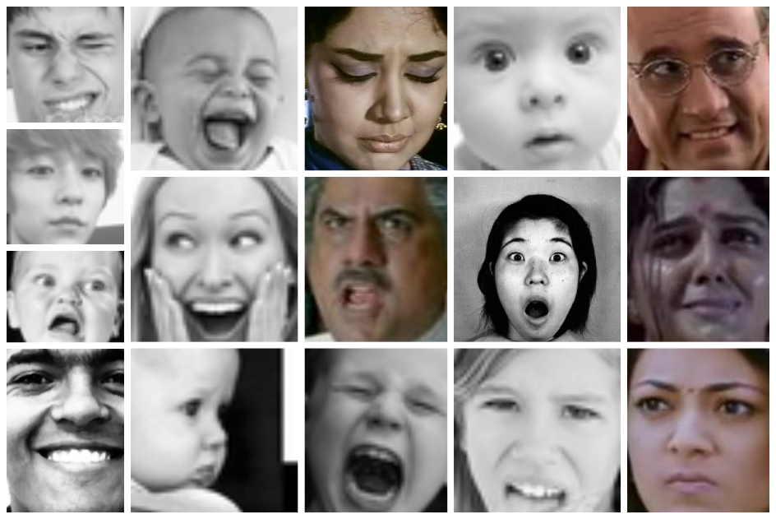

Figure 2: Samples from the collected dataset combined with FER-2013

**Dataset**:

Neural networks, and deep networks in particular, are known for their need for large amounts of training data. Moreover, the choice of images used for training are responsible for a big part of the performance of the eventual model. This implies the need for a both high qualitative and quantitative dataset. For emotion recognition, several datasets are available for research, varying from a few hundred high resolution photos to tens of thousands smaller images.

We used the videos from YouTube to collect the data. For gathering the dataset, I had made a python script, which used haar-cascade.xml file to identify the faces from the YouTube videos.

Haar-Cascade is a machine learning object detection algorithm used to identify objects in an image or video and based on the concept of **​​** features proposed by Paul Viola and Michael Jones in their paper "Rapid Object Detection using a Boosted Cascade of Simple Features" in 2001.

OpenCV comes with a trainer as well as detector. If you want to train your own classifier for any object like car, planes etc. you can use OpenCV to create one.

for (x,y,w,h) in faces:

img = cv2.rectangle(img,(x,y),(x+w,y+h),(255,0,0),2)

roi_gray = gray[y:y+h, x:x+w]

roi_color = img[y:y+h, x:x+w]

eyes = eye_cascade.detectMultiScale(roi_gray)

for (ex,ey,ew,eh) in eyes:

cv2.rectangle(roi_color,(ex,ey),(ex+ew,ey+eh),(0,255,0),2)

cv2.imshow('img',img)

The identified faces were cropped and stored into local drive with the help of another script.

if len(rects) >= 0:

# Draw a rectangle around the faces

for (x, y, w, h) in rects:

face = gray[y:y+h,x:x+w]

cv2.rectangle(img, (x, y), (x + w, y + h), (0, 255, 0), 2)

cv2.imwrite('/Dataset/'+str(i) + '.jpg', face)

i+=1

# Display the resulting frame

cv2.imshow('Face Detection on Video', img)

Figure 3: Result of using the Haar-cascade file

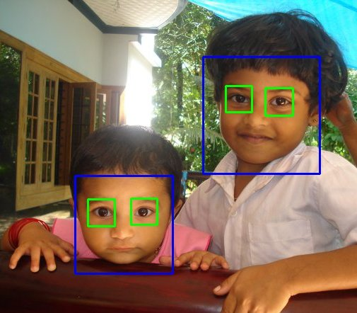

Later, I combined the collected dataset with the already available FER 2013 dataset.

**Training of model – Using Deep Convolutional Neural Network**:

First of all, what is a neural network?

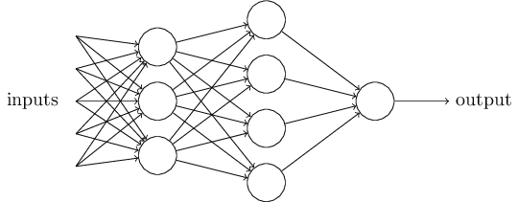   
Figure 4: Image depicting a simple neural network.

Creating a machine learning algorithm ultimately means building a model that outputs correct information. Given that we've provided input data for now think of this model as a black box we feed input and it delivers an output.

Now, first thing to do is - we must train the model. Training is a central concept in machine learning as this is the process through which the model learns how to make sense of the input data. Once we have trained our model we can simply feed it with data and obtain an output.

The basic logic behind training an algorithm involves four ingredients:

1. Data
2. Model
3. Objective function
4. Optimization algorithm.

First we must prepare a certain amount of **data** to train with.

Usually this is historical data which is readily available, like I have used the FER 2013 dataset which was readily available.

Second we need a **model**. The simplest model we can train is a linear model. That would mean to find some coefficients multiply each variable with them and sum everything to get the output.

The third ingredient is the **objective function**. So far we took data fed it to the model and obtained an output. We want this output to be as close to reality as possible. That's where the objective function comes in. It estimates how correct the models outputs are. On average the entire machine learning framework boils down to optimizing this function.  
For example, if my function is measuring the prediction error of the model I would want to minimize this error or in other words minimize the objective function.

Our final ingredient is the **optimization algorithm**. It consists of the mechanics through which we vary the parameters of the model to optimize the objective function.

We would calculate the objective function then we would choose the model with the highest predictive. The machine learning process is iterative. We feed data into the model and compare the accuracy through the objective function. Then we vary the models parameters and repeat the operation. When we reach a point after which we can no longer optimize or we don't need to we would stop since we would have found a good enough solution to our problem.

**Modelling**:

Sequential is the function which indicates that we are laying down the model it takes as arguments. A **Sequential model** is appropriate for a plain stack of layers where each layer has exactly one input tensor and one output tensor.

**Layer**:

A **layer** is the highest-level building block in deep learning. A **layer** is a container that usually receives weighted input, transforms it with a set of mostly non-linear functions and then passes these values as output to the next layer. **Single layer neural networks** are very limited for simple tasks, deeper NN can perform far better than a single layer. **Hidden layers**, simply put, are layers of mathematical functions each designed to produce an output specific to an intended result.

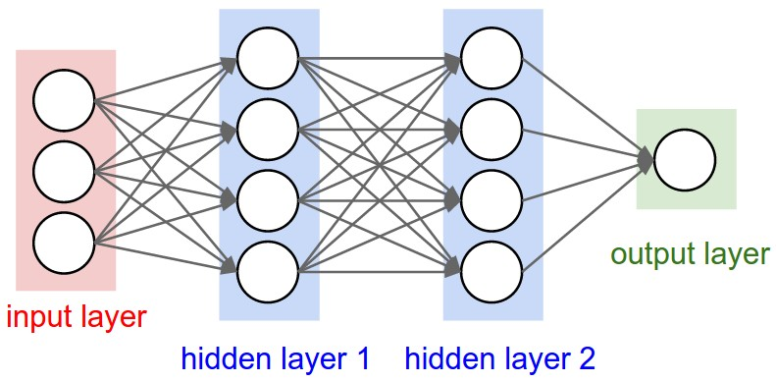

Figure 5: Layers in Neural Network

A **convolution** is the simple application of a filter to an input that results in an activation.

A**pooling layer**is another building block of a CNN. Its function is to progressively **reduce** the spatial **size** of the representation to reduce the amount of **parameters** and **computation** in the network. **Pooling layer** operates on each feature map independently. The most common approach used in **pooling is max pooling**.

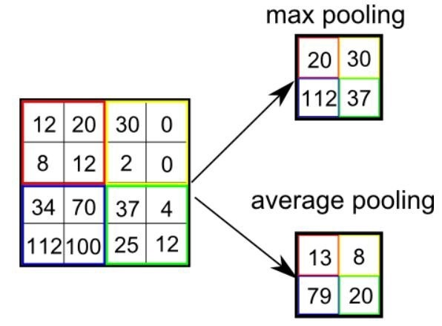

Figure 6: Max Pooling in Neural Network

**Rectifier**:

In the context of artificial neural networks, the rectifier **is an activation function** defined as the positive part of its argument: where x is the input to a neuron. A unit employing the rectifier is also called a **rectified linear unit** (ReLU). **Rectified linear units** find applications in computer vision and speech recognition using deep neural nets.

  
Figure 7: Comparison between ReLU and sigmoid functions

**Kernel Size**:

In image processing a **Kernel** is simply a 2-dimensional matrix of numbers. While this matrix can range in **dimensions**.

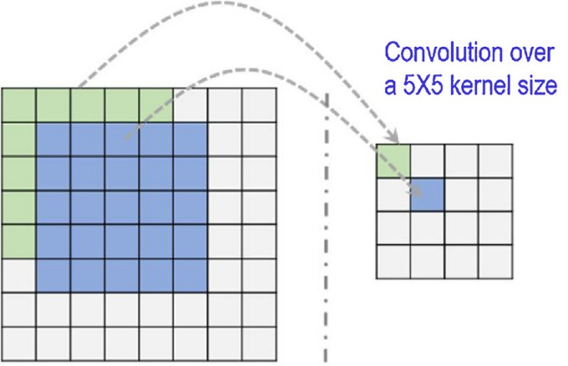  
Figure 8: Working of Convolution over a 5x5 kernel size

**Softmax Activation**:

Softmax Activation is a function, similar to ReLU, that takes as input a vector z of K real numbers, and normalizes it into a probability distribution consisting of K probabilities proportional to the exponentials of the input numbers.

**Softmax** functions are multi-class sigmoid, meaning they are **used** in determining probability of multiple classes at once. Since the outputs of a **Softmax** function can be interpreted as a probability (i.e. they must sum to 1), a **Softmax** layer is typically the final layer **used** in neural network functions.

**Dropout**:

Dropout is a technique used to prevent a model from overfitting. **Dropout** works by randomly setting the outgoing edges of hidden units (neurons that make up hidden **layers**) to 0 at each update of the training phase.

# the model

model = Sequential() # stack layers model. tf.keras model

# layer 1. input layer

model.add(Conv2D(32, kernel_size=(3, 3), activation='relu',

input_shape=(48, 48, 1)))

model.add(Conv2D(64, kernel_size=(3, 3), activation='relu'))

# kernel size is to divide 48x48 imge into 3x3 activation fn

model.add(MaxPooling2D(pool_size=(2, 2)))

# take the max of that region and create a new, output matrix

model.add(Dropout(0.25))

# preventing the model from overfitting, where randomly selected neurons are dropped out

model.add(Conv2D(128, kernel_size=(3, 3), activation='relu'))

model.add(MaxPooling2D(pool_size=(2, 2)))

model.add(Conv2D(128, kernel_size=(3, 3), activation='relu'))

model.add(MaxPooling2D(pool_size=(2, 2)))

model.add(Dropout(0.25))

model.add(Flatten()) # convert matrix into vector

model.add(Dense(1024, activation='relu'))

model.add(Dropout(0.5)) # dropout reduces overfitting.

model.add(Dense(7, activation='softmax')) # output layer

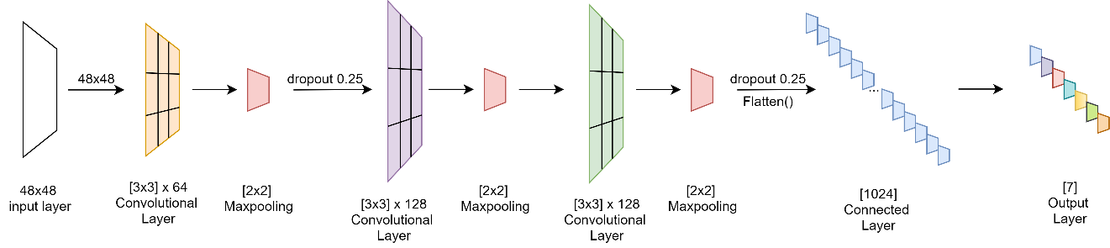

Figure 9: Neural Network architecture; an overview

**Model Training Graph**:

The software detects emotions on all faces in the webcam feed. With a simple 4-layer CNN, the test accuracy reached 73.2% in 50 epochs.

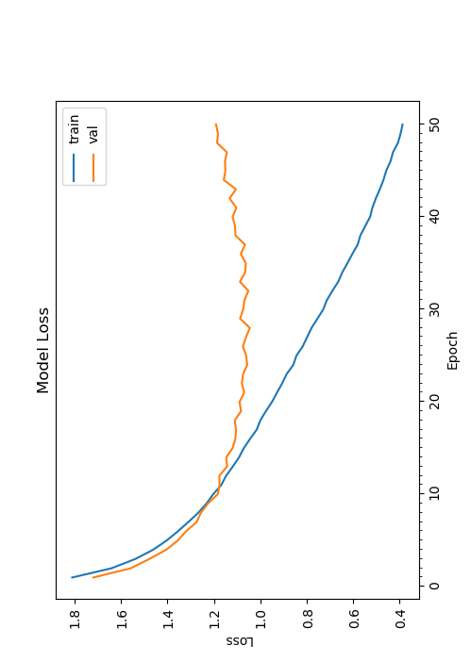  
Figure 10: Epochs and Model Loss while training

**Application and Output (Testing)**:

model.load_weights('model.h5')

# prevents openCL usage and unnecessary logging messages

cv2.ocl.setUseOpenCL(False)

# dictionary which assigns each label an emotion (alphabetical order)

emotion_dict = {

0: "Angry",

1: "Disgusted",

2: "Fearful",

3: "Happy",

4: "Neutral",

5: "Sad",

6: "Surprised" }

# start the webcam feed

cap = cv2.VideoCapture(0)

while True:

# Find haar cascade to draw bounding box around face

ret, frame = cap.read()

if not ret:

break

facecasc =

cv2.CascadeClassifier('haarcascade_frontalface_default.xml')

gray = cv2.cvtColor(frame, cv2.COLOR_BGR2GRAY)

faces = facecasc.detectMultiScale(gray,scaleFactor=1.3,

minNeighbors=5)

for (x, y, w, h) in faces:

cv2.rectangle(frame, (x, y-50), (x+w, y+h+10), (255, 0, 0), 2)

roi_gray = gray[y:y + h, x:x + w]

cropped_img = np.expand_dims(np.expand_dims(cv2.resize(roi_gray,

(48, 48)), -1), 0)

prediction = model.predict(cropped_img)

maxindex = int(np.argmax(prediction))

cv2.putText(frame, emotion_dict[maxindex], (x+20, y-60),

cv2.FONT_HERSHEY_SIMPLEX, 1, (255, 255, 255), 2, cv2.LINE_AA)

cv2.imshow('Video', cv2.resize(frame,(1600,960),interpolation =

cv2.INTER_CUBIC))

if cv2.waitKey(1) & 0xFF == ord('q'):

break

cap.release()

With use of the OpenCV face recognition, the appearing face(s) from real-time video is tracked, extracted, and scaled to usable 48x48 input.

This data is then fed to the input of the neural network model, which in its turn returns the values of the output layer.

The output with the highest value is assumed to be the current emotion of the user, and is depicted by a green square box on the face(s).

Though, it encounters problems when shadows are present on the face of the subject. All emotions are easily recognized when acted by the user.

**Confusion Matrix**:

A confusion matrix, also known as an error matrix, is a specific table layout that allows visualization of the performance of the algorithm.

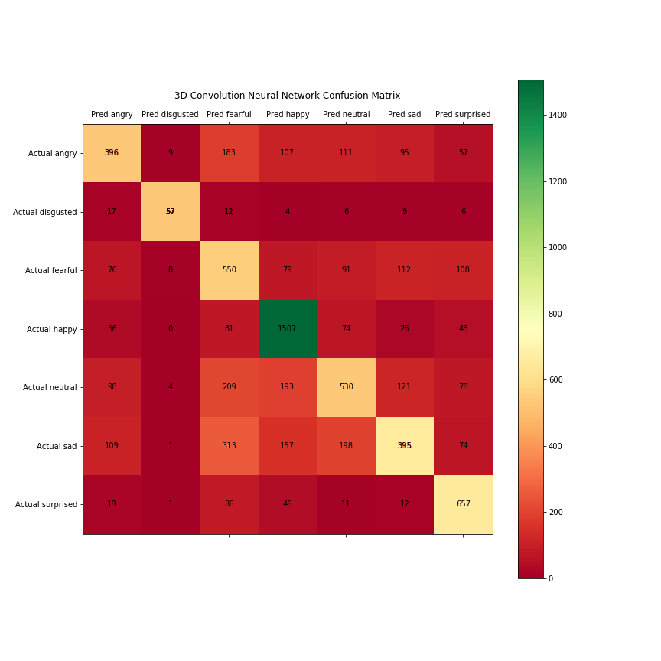  
Figure 11: Confusion Matrix of the model

**Interface (Screenshots)**

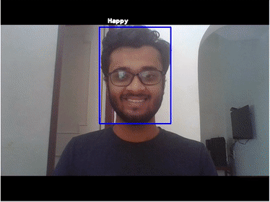  
Figure 12: Computer Vision(CV) detecting a Happy face.  
  
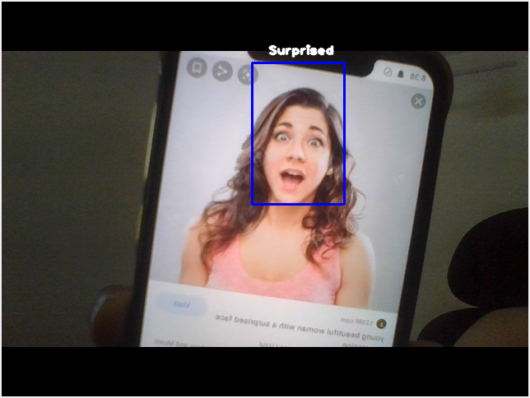  
Figure 13: Computer Vision(CV) detecting a Surprised face.

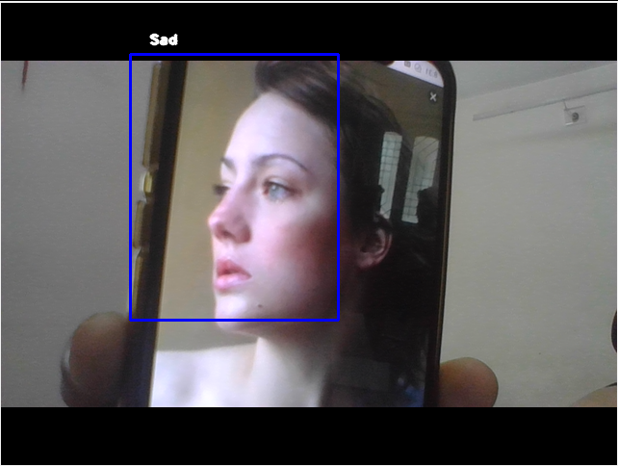  
Figure 14: Computer Vision(CV) detecting a Sad face.  
  
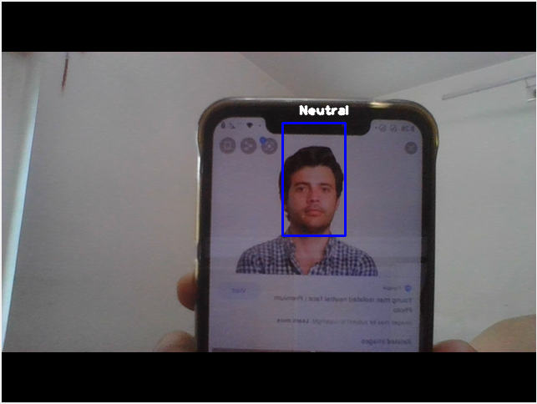  
Figure 15: Computer Vision(CV) detecting a Neutral face.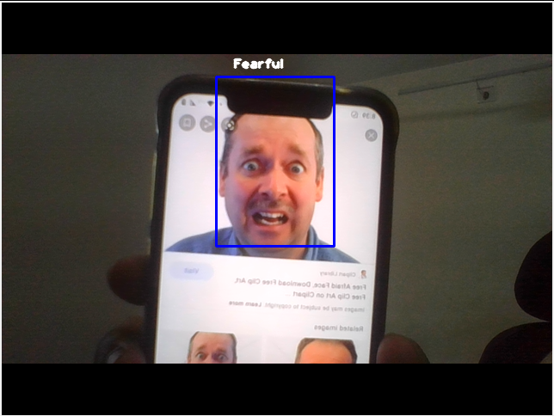   
Figure 16: Computer Vision(CV) detecting a Fearful face.

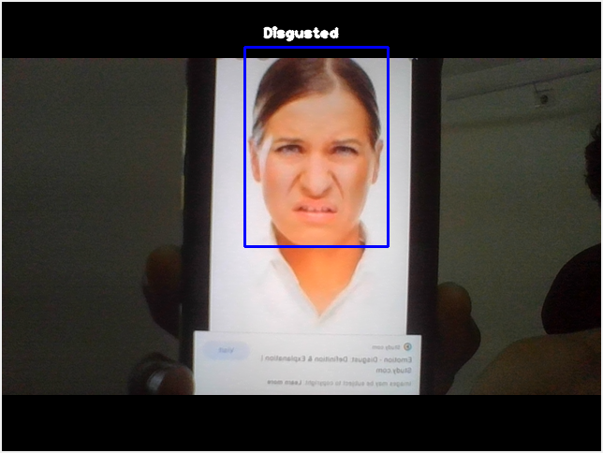   
Figure 17: Computer Vision(CV) detecting a Disgusted face.

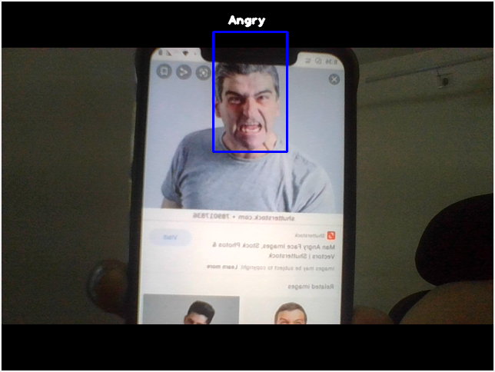  
Figure 18: Computer Vision(CV) detecting an Angry face.

**Limitations and Future Enhancements**:

Limitations:

1. This does not imply it is reading your innermost feelings -- it only reads what you express outwardly.
2. The accuracy is very low, as there is a lot of complexity in human faces and a human face can show multiple feelings at a time.
3. Deploying the project is costly for Mass Surveillance.

Future Enhancements:

1. First thing is to improve the accuracy of the model by entirely changing the dataset or optimize the model further. This can be done using RNNs or Recurrent Neural Network rather than CNN which is used in making if this project. Although, RNNs are used for Sound Processing mainly and not for Image processing.

**Assignment 2: Data Mining**

**Data Mining**:

Data mining is a process of discovering patterns in large data sets involving methods at the intersection of machine learning, statistics, and database systems. While the detected emotions were collected and stored into the database, I performed analysis on the MySQL database. The insights showed what I actually felt. Due to Covid19 situation I could not perform the tests in the real world, so I performed it on myself.

Whenever I coded, my webcam recognises my emotions and stored it into the database.

Found these fascinating insights after interpreting the database:   
**37% of the time I'm nervous - “whether my code will work or not!”  
And, 30% of the time I'm surprised – “why this code worked?!”**

Here is the pie chart showing what I felt while I sat in front of the computer:

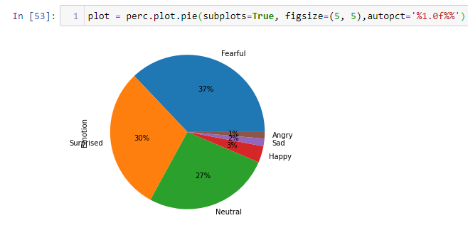  
Figure 19: Pie Chart to classify my Emotions and what I felt during a day

Here are the screenshots depicting the code which I wrote to interpret the MySQL database, where collected emotions were stored.

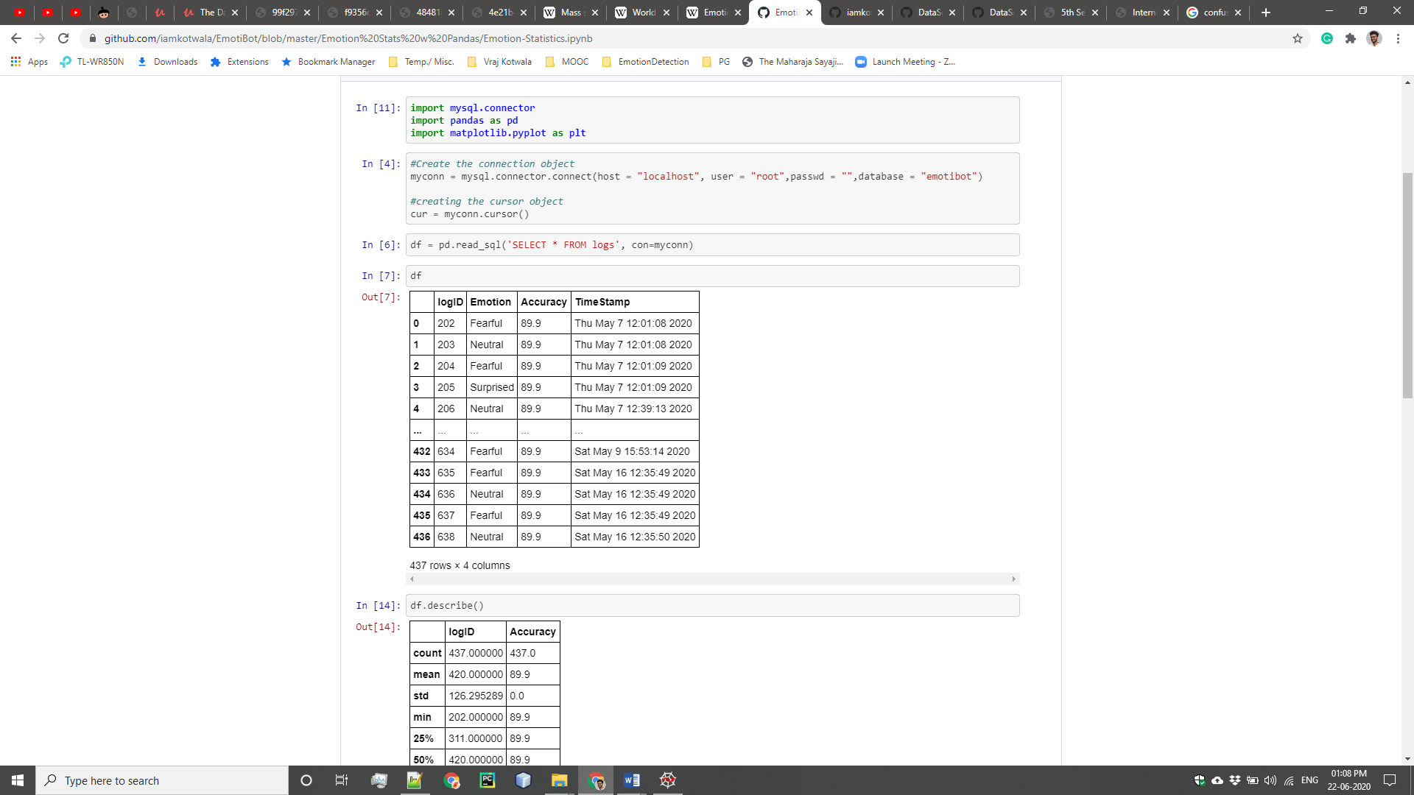  
Figure 20: Importing relevant libraries and looking at the Pandas dataframe

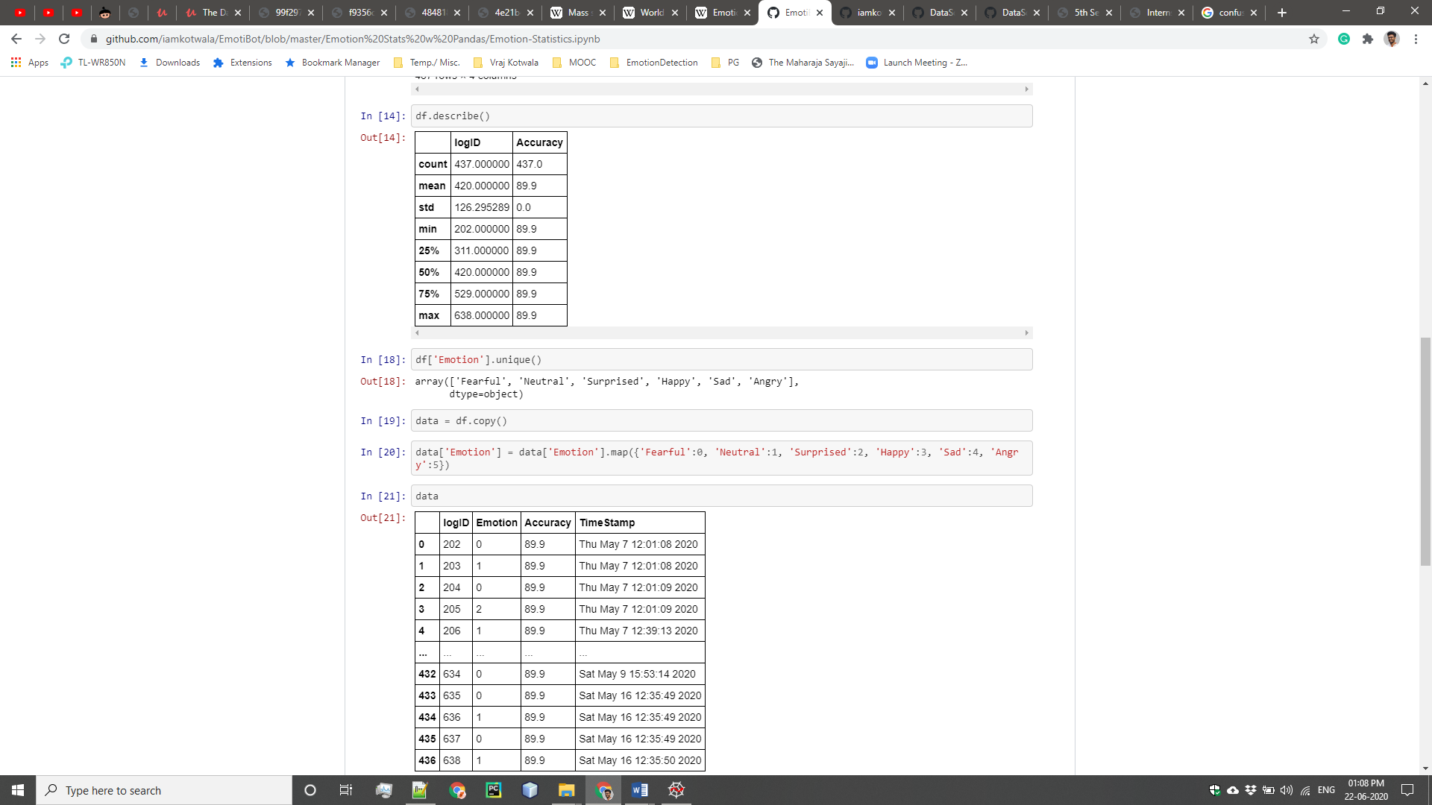  
Figure 21: Describing the data and turning it into categorical data

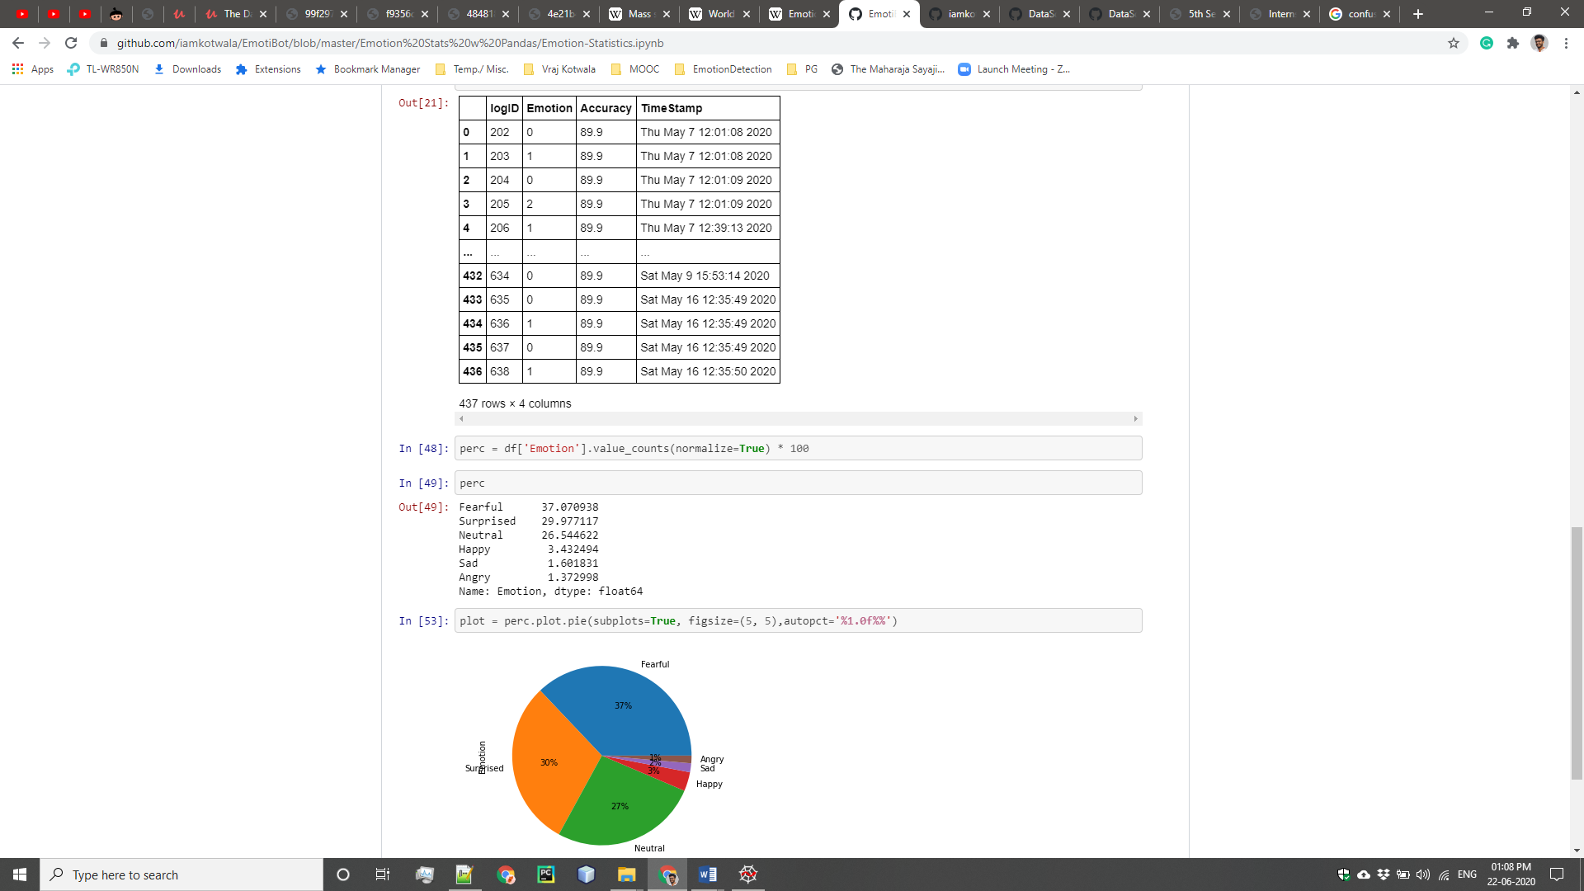  
Figure 22: What percentage of the emotions are there and plotting it into a pie chart.

**Assignment 3: Regression and NN on MNIST**

**Other Exercises on Regression and Neural Network**:

I created the SAT-GPA score prediction using Scikit-Learn, Stats-Models, NumPy where I've used the OLS model to practice on.

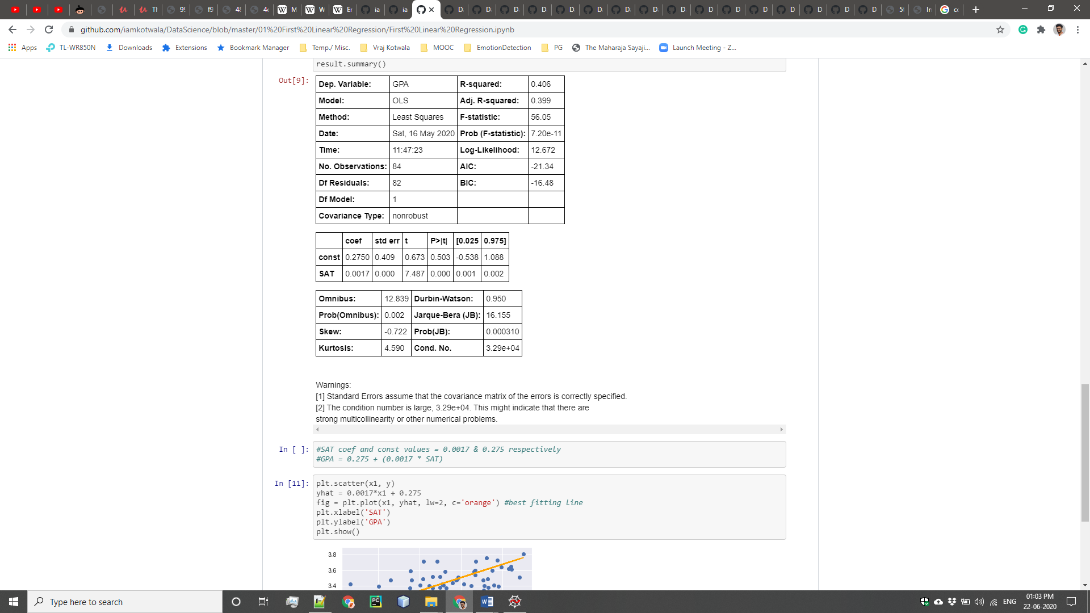  
Figure 23: summary of the OLS model

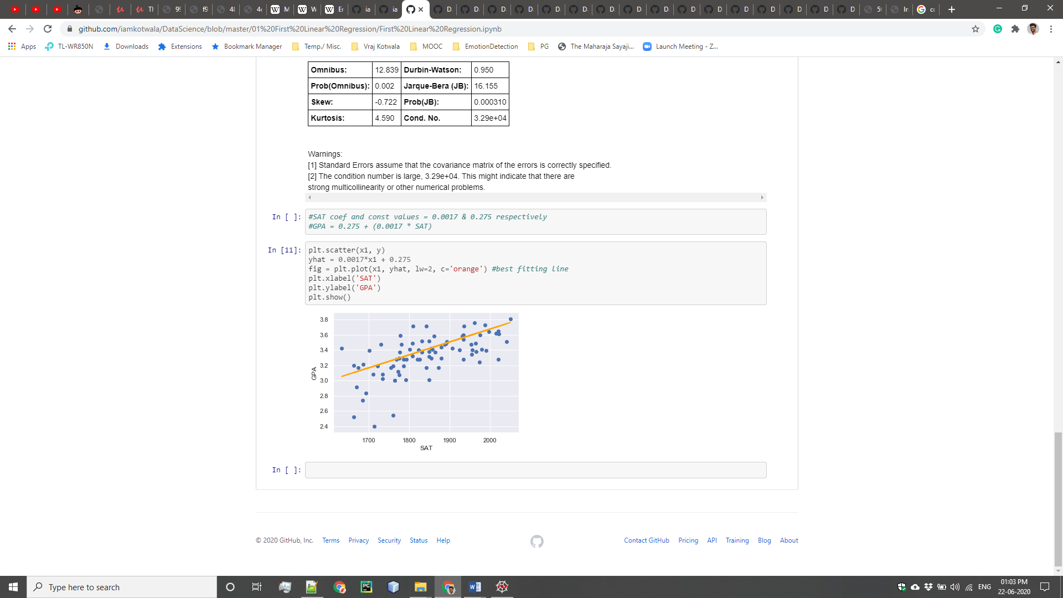  
Figure 24: Regression and plotting of the SAT-GPA scores

**Neural Network on MNIST dataset**:

The MNIST dataset provides 70,000 images (28x28 pixels) of handwritten digits (1 digit per image).

The goal is to write an algorithm that detects the math digits. Since there are only 10 digits (0, 1, 2, 3, 4, 5, 6, 7, 8, 9), this is a classification problem with 10 classes.

I built the neural network with 2 hidden layers.

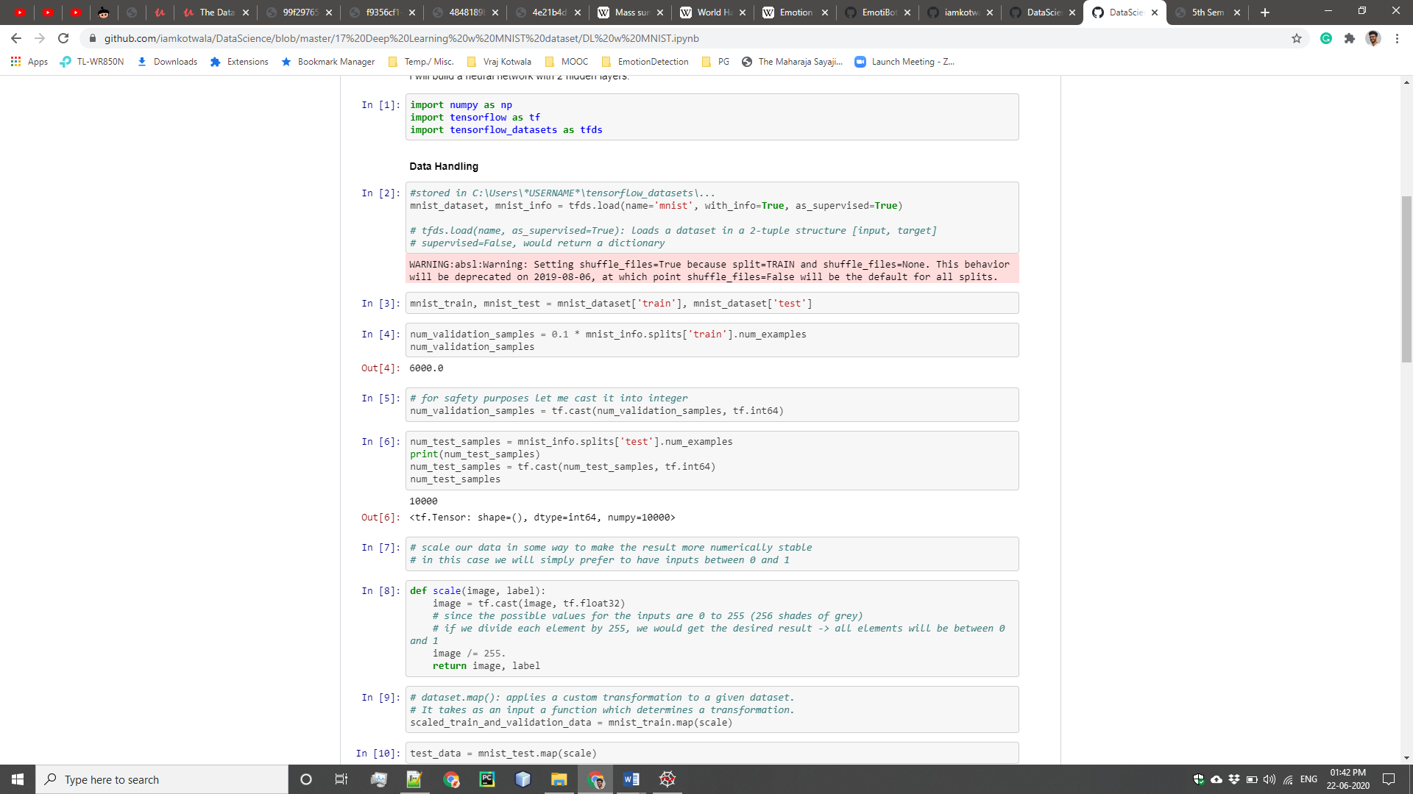  
Figure 25: MNIST data pre-processing

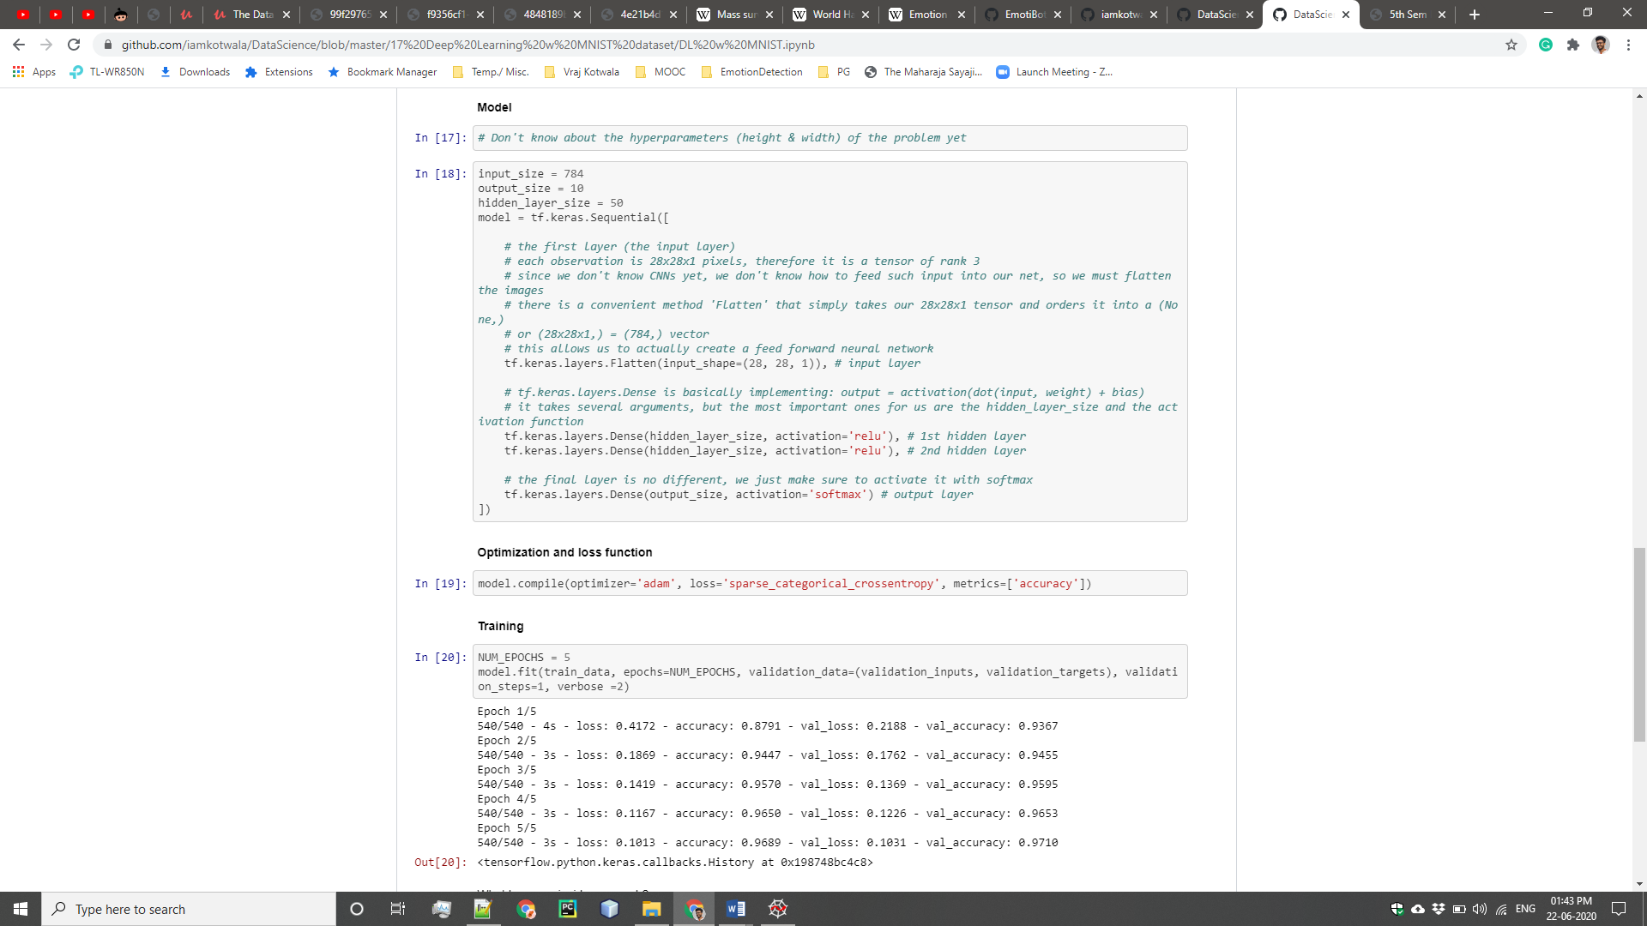  
Figure 26: MNIST – creating the model, optimising and training.

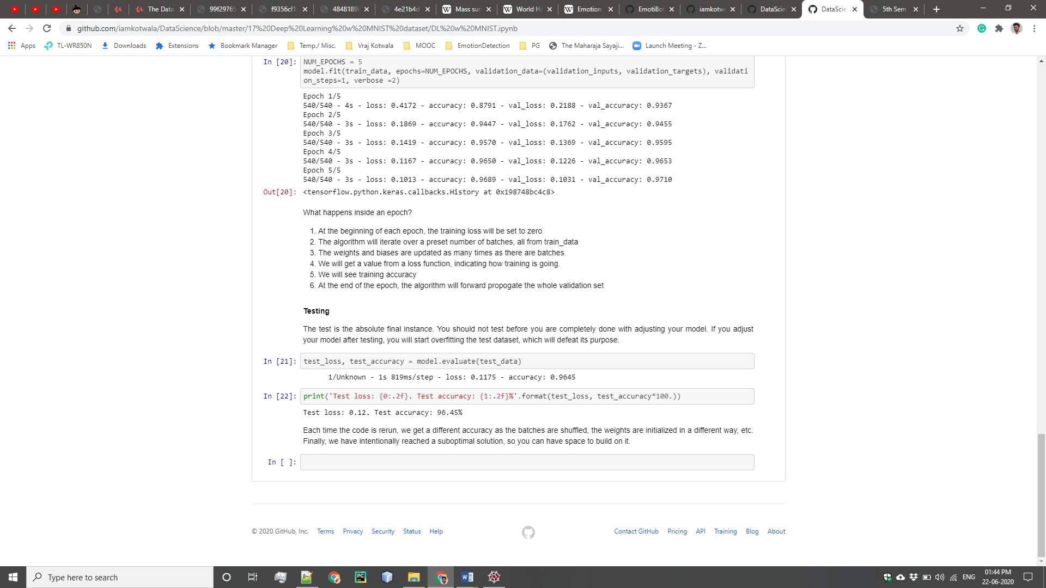  
Figure 27: Testing the MNIST dataset

**Work Division** (with respect to time):

*January:*

1. Data Collection

*February:*

1. Data Collection
2. *Trainings on Regression, Clustering, Logistic Regression using Scikit-Learn and various packages*

*March:*

1. *Theory and study of research papers*
2. *Creating Neural Network for MNIST data.*
3. Training of the Model

*April:*

1. Testing
2. Generating Report using Pandas and SQL

*May*:

1. Tweaking and Optimizing the Model
2. Testing

2.4 **Challenges or difficulties faced during assignment**:

I knew nothing practical before I joined as an intern. I knew the theory part of it, but implementing it was the most difficult part. Also, there was a huge learning gap and a steep learning curve while learning the concepts of Machine Learning and Deep Learning altogether.

Second most difficult thing was data collection from scratch. We had no idea that we can use an available dataset from websites like Kaggle. It took us almost a month to gather the dataset, and it was only possible with the help of my intern-colleague.

Training and tweaking the model (optimising) was also a difficult process There were many parameters. I had no patience as the training used to take minimum of 2 hours.

Moreover, working from home during pandemic situation as a result by Covid-19, caused a delay in work by a month. Some things are difficult to explain over a phone call or a video call. But, I’m grateful for apps like Zoom calls, and Google-Meet which made my work a little easier.

2.5 **Correlating with the Academics**:

Genuinely, the knowledge which I gained in my academic program helped me to complete my internship. There is no doubt about it. In BCA program we were taught many different courses which gave me good knowledge from many different fields. Courses like, C++, Data Structures, Computer Networks, Software Engineering, Communication Skills and many more.

It was because of the support of teachers and lessons that I could give my best to the assignments which I undertook as an intern in Rishabh Software and was able to apply the knowledge that I acquired under their guidance.

III. Corporate Culture

3.1 **Working Atmosphere**:

Rishabh Software is a good company for better future. It has an excellent platform to learn and grow in professional career. It has an open culture to work in a collaborative atmosphere. Moreover, I got an exposure to multiple facets of professional roles. Colleagues are friendly, and management is cooperative.

In fact, all the employees in the organisation are friendly and helpful. All of them have a good experience in their particular field.

My guide, Dr. Falguni Ranadive and Mr Gagan Dubey have shown immense trust and patience on me which made me more devoted towards my work.

One thing which I didn’t liked about the corporate culture is that it takes more time to execute a given project. As they say, “If you want to go fast, work alone. But, if you want to go far, work in team”.

3.2 **Culture within the Organization**:

3.2.1 **Cultural norms explained to me**:

Several cultural norms and guidelines were explained to me. I’m including the parts of mail which I received after joining the organisation which stated the norms below:

As an intern with RISE, you are now a representative of the company and hence what you display, physically or through your behaviour and etiquettes matter a lot. We have listed some for your reference and action, however no charter/ rules /policy can be written to cover all situations. Each individual must exercise his or her high ethical standards.

**Access control card system:**

1. The access control cards will be issued to every individual by the HR department after they sign the ID register maintained for this purpose.

2. The card once issued, binds the use for the particular individual and cannot be used or accessed by any other person than the one who owns the card.

3. It is a must to flash the card to the IN card reader during entry and to the OUT card reader during exit, even if the door is found open. PLEASE FLASH YOUR CARD AT TIME OF EACH ENTRY/ EXIT.

4. Do not Misuse the access authority given to you. What constitutes Misuse of your card?

• Allowing any other person to gain entry or exit.

• Being in possession of more than one Access card.

• Allowing another person to make use of your card for any purpose.

5. Lost and stolen cards must be reported promptly to the HR department.

**Use of Company Resources:**

1. Use of company resources, assets and consumable items, including time, materials, and equipment shall be only for business purposes and training benefit.

2. Any personal use, without proper permission, tantamount to misuse of Company property.

3. Use of training rooms, desk, projector or any other fixed asset is to done with care.

4. Wi-Fi will be enabled on your personal systems to assist you with your training. Misusing of this facility is a misconduct.

5. Viewing or accessing unwanted sites on the internet is strictly prohibited. This may result in disciplinary action, up to and including termination.

6. Make sure to switch off lights, fans, Air-conditioners, computers, UPS when not in use/before leaving for the day.

**Workplace Cleanliness**:

1. All employees are expected to keep their desks and surroundings neat and tidy.

2. They should keep office premises clean e.g. throwing waste in waste bins, wiping shoes on doormats, etc.

3. In cafeteria, only vegetarian food would be entertained.

4. When celebrating an event, do not dirty the floor or tables un-necessarily.

5. Consumption of chewing gums and tobacco is grossly discouraged.

**Mobile Use**:

1. The use of Mobile phones in office premises should be kept minimum.

2. Usage of mobile phones while in a session is strictly prohibited.

3. To attend to important/emergency calls, you need to come out of their work areas and take/place the call in the open areas.

4. Mobile phones are expected to be kept on vibration or silent mode by all employees. This is to ensure that we don’t disturb others in the office premises.

**Physical Safety**:

1. You are expected to treat fellow employees, directors, customers and vendors with courtesy and resolve any difference in a professional, non-abusive and non-threatening manner.

2. Rishabh's policy is committed to provide to its employees a work environment free from sexual or racial harassment.

3. Rishabh does not permit employees, contractors or visitors to bring weapons onto any part of Rishabh’s property, including parking areas.

4. Discussions pertaining to sensitive subjects like, religion, politics, current affairs etc. is best avoided.

**Dress Code**:

* + - 1. Workdays Dress Code: Need to wear formal clothes throughout the week days as indicated Below: (Monday to Thursday)

• Men: Shirt, formal trousers, Shoes and socks.

• Women: Salwar-Kurta, Saree, Shirt, Pant, Formal Skirt, Shoes or Sandals. Flip-flops (shower type shoes) and thong-type shoes are not permitted.

* + - 1. Weekend Dress Code: Employees can wear casual clothes during the last working day of the week:

• Men: T-shirt, Jeans, and Sandals

• Women: T-shirt, Jeans, Skirt (no shorter than the knee length, sitting or standing), normal footwear. Understand what you wear.

3.2.2 **Cultural norms I picked up**:

There are several norms which I picked up as an intern.

1. Sometimes, I used to help others on their projects as well.
2. I used the company resources only when needed and that too for company’s benefit.
3. I used to reach office on time, always.
4. I always used to dress formally even on Fridays.

3.2.3 **Insights gained about corporate culture that I will take into consideration when searching for full time employment**:

The internship helped me to apply the knowledge, which I gathered from my education, on to a real time work experience. I got a chance to use the knowledge regarding my field on the better and larger way.

My future career goals are to be a part of high profiled and well established IT organisation with a career boosting growth option so that I can benefit the organisation and myself as an individual, and apply all the knowledge I acquired to come up with revolutionizing software that helps in completing the task efficiently.

Some of the learnings to grow in corporate culture:

1. Exhibiting knowledge, I have been imparted and skills that make me a uniquely valuable employee.
2. Continue to educate to update my knowledge and skill for my position, and position I desire to hold in future.
3. Manage my tasks and actions to contribute to the performance outcomes set for my department and company.
4. Build relationship outside the company that can be leveraged for its benefit.
5. Relate to people who have the capacity to mentor me and widen my scope of encouragement.
6. Communicate and use all opportunities to strengthen my network throughout the organization.

IV. Communication

4.1 **Ways in which I communicated within and outside the organization**:

There was no restriction to interact to other employee so we usually communicate verbally with each other.

Various modes of communication were used and outside the organisation, like emails, phone calls, and video calls. Out of which email was considered to one of the most preferable mode of communication. It allowed to respond effectively and wisely at one’s own time. Also, it is considered to be one of the most professional mode.

Although, due to the Covid19 situation, we switched majority of our communication from mail to conference calls, as it was much efficient for that circumstance.

We also created a WhatsApp group where all the updates were discussed for a particular time being.

4.2 **Example of good communication skills utilized by the employees**:

There are many examples of good communication skills utilized by the employees, and I would like to mention a few.

1. Listening:  
   The employees were active listeners. They used to involve in paying close attention to what the other person is saying, asking and clarifying questions, and rephrasing what the person says to ensure understanding.
2. Nonverbal Communication:  
   They were also good at expressing through [body language](https://www.thebalancecareers.com/body-language-tips-for-your-next-job-interview-2060576), eye contact and hand gestures.
3. Confidence:  
   They were confident while interacting with one another.
4. Respect:  
   Employees always used to respect each other and their ideas. Many of them used person's name, and make an eye contact while interacting. Many employees make the other person feel appreciated at the organisation.

4.3 **Methods to improve the effectiveness of communication within the organization**:

Effective ways to learn precise, professional oral and written communication skills include:

1. People in the organisation, such as a supervisor, should provide feedback on strengths and weaknesses as a communicator.
2. Alternatively, the employees should analyse the strengths and techniques of excellent communicators. They should even imitate strong communicators.
3. When sending a message, employees must think of the target audience, being sure to use terms and phrases that readers or listeners will understand.
4. For example, texts or e-mails should avoid using abbreviations that the receiver may not recognize. To respect others’ time, communication should aim for briefness and without sacrificing clarity and completeness.
5. Often, messages are poorly structured, missing specific subject lines, slow in getting to the point, or too long to warrant being read in their entirety.
6. It can be challenging to convey the message in the right tone or avoid the wrong one in electronic communication.   
   The absence of non-verbal cues, such as tone of voice or body language, means that written communication can be more easily misinterpreted and even cause offense.

V. Career Reflection

5.1 **Internship related to field of study**:

Internship Domain: **Machine Learning & Data Mining**

Machine learning is the study of computer algorithms that improve automatically through experience. It is seen as a subset of artificial intelligence. Data mining is a process of discovering patterns in large data sets involving methods at the intersection of machine learning, statistics, and database systems.

5.2 **The technologies and subjects learned during the internship and domain in which I’m going to start my career**:

Some of the technologies which I learnt during the Internship and in lockdown:

1. GitHub
2. Advance Python and its packages:
   1. [Numpy](https://numpy.org/)
   2. [Pandas](https://pandas.pydata.org/)
   3. [Matplotlib](https://matplotlib.org/)
   4. [Scikit Learn](https://scikit-learn.org/stable/)
   5. [StatsModels](https://www.statsmodels.org/stable/index.html)
3. Advance Statistics:
   1. frequency distribution,
   2. skewness,
   3. variance,
   4. standard deviation,
   5. covariance, correlation,
   6. central error,
   7. central limit theorem,
   8. hypothesis testing,
   9. p-value.
4. Machine Learning
5. Deep Learning
6. TensorFlow 2
7. Big Data
8. Data Science
9. Data Mining
10. AWS Cloud

I believe that there is a lot more to explore before I start my career. For example, I want to explore Blockchain, Natural Language Processing (NLP), IoT with AI, and there are many more on my list. Also, before starting my career I want to pursue my post-graduate degree.

**Conclusion: Experience and Learning**

Building a whole system from scratch considering all the aspects of software

engineering from gathering requirements to planning, designing, testing was a lifetime experience in itself.

Building a Deep Learning model using Tensorflow, working with database to gain insights, assembling everything to get the final output under the guidance of our mentors and the project guide taught me how different is the real world.

I faced many difficulties but having a mentor/guide makes everything much easier,

every time we were stuck somewhere our guide was there to help us, challenged us to

solve the queries on our own and in the end always used to give us the finest solutions.

I learned to solve real problems, learned lot of new techniques and technologies

during this period. This project helped us to get out of our comfort zone, learn new

technologies and their implementations.

I learned to design and model the system. The last 5 months were a roller coaster ride for me consisting of knowledge gain, experience, life lessons, team work, real time dealing.

On a concluding note I would like to share my experience that internship is a key element in the technical writing of student’s professional preparation and this internship report is a key element in the internship experience.

It is through this report that I challenged my critical and analytical faculties and was able to demonstrate a newly found skills; as a professional communicator.

**References and Bibliography:**

1. <https://www.udemy.com/course/the-data-science-course-complete-data-science-bootcamp/> : Data Science Boot camp Course, where I learnt most of the concepts related to statistics, and basics of ML, DL, and Neural Networks
2. <http://neuralnetworksanddeeplearning.com/chap1.html> : Understanding the basics of neural networks and deep learning
3. <https://statisticalhorizons.com/multicollinearity> : Understanding the concepts of stats
4. <https://www.statsmodels.org/stable/generated/statsmodels.stats.outliers_influence.variance_inflation_factor.html> : Documentation for Stats Models package
5. <https://github.com/atulapra/Emotion-detection> : Research done by an IITian on emotion recognition
6. <https://keras.io/examples/cifar10_cnn/> : Practising Image recognition with Neural Network on CIFAR10 dataset provided by Keras.
7. <https://towardsdatascience.com/epoch-vs-iterations-vs-batch-size-4dfb9c7ce9c9> : Epoch and iterations and their differences
8. <https://www.quora.com/What-is-epochs-in-machine-learning> : What is an Epoch in ML
9. <https://www.quora.com/How-and-why-having-the-same-number-of-dummy-variables-as-categories-is-problematic-in-linear-regression-Dummy-variable-trap-Im-looking-for-a-purely-mathematical-not-intuitive-explanation-Also-please-avoid-using-the/answer/Iliya-Valchanov?share=9494e990&srid=uX7Kg> : Dummy Variables for categorical data in ML
10. <https://en.wikipedia.org/wiki/Emotion_recognition> : Reading the available research
11. <https://en.wikipedia.org/wiki/World_Happiness_Report> : Application of Emotion Recognition Systems
12. <https://en.wikipedia.org/wiki/Mass_surveillance> : Application of Emotion Recognition Systems
13. <https://www.indeed.com/career-advice/career-development/how-to-write-an-internship-report> : Report writing
14. <https://vrajkotwala.com/blog/Data-Science-Beginner> : How to bridge learning gaps with data science.
15. <http://www.willberger.org/cascade-haar-explained/> : What is Haar Cascade and how to work with it in OpenCV
16. <https://docs.opencv.org/3.4/db/d28/tutorial_cascade_classifier.html> : Documentation on Haar Cascade.
17. <https://www.youtube.com/watch?v=aircAruvnKk> : Visualizing the Neural Network
18. <https://www.tensorflow.org/api_docs/python/tf/keras/Sequential> : Building a sequential model in Tensorflow
19. <https://stackoverflow.com/questions/35345191/what-is-a-layer-in-a-neural-network> : Layer in Neural Network
20. <https://www.quora.com/What-is-max-pooling-in-convolutional-neural-networks> : Max pooling
21. <https://www.youtube.com/playlist?list=PLC58778F28211FA19> : Learning the basics of Applied Probability
22. <https://github.com/iamkotwala/DataScience> : Problems on Data Science.
23. <https://www.youtube.com/watch?v=xtOg44r6dsE> : ML types
24. <https://www.tensorflow.org/learn> : Tensorflow documentation
25. <http://yann.lecun.com/exdb/mnist/> : MNIST dataset documentation
26. <https://en.wikipedia.org/wiki/MNIST_database> : MNIST wiki
27. <https://www.rishabhsoft.com/> : Company’s website
28. <https://monkeylearn.com/blog/introduction-to-support-vector-machines-svm/#:~:text=A%20support%20vector%20machine%20(SVM,on%20a%20text%20classification%20problem.> : Support Vector Machines
29. <https://www.youtube.com/watch?v=AoJQS10Ewn4> : Objective Function
30. <https://mech.iitm.ac.in/nspch52.pdf> : Optimization Algorithms
31. <https://www.dataschool.io/simple-guide-to-confusion-matrix-terminology/#:~:text=A%20confusion%20matrix%20is%20a,related%20terminology%20can%20be%20confusing.> : Confusion Matrix
32. <https://pandas.pydata.org/> : Pandas Documentation
33. <https://matplotlib.org/> : Matplotlib Documentation
34. <https://scikit-learn.org/stable/> : Scikit Learn Documentation
35. <https://www.statsmodels.org/stable/index.html> : Stats Models Documentation
36. <https://numpy.org/> : NumPy Documentation